Final Project - Intro. To Embedded Systems S23

Aidan Sharpe, Elise Heim

Section Number 3

horizontal line

# Project Description

Our project is going to consist of a synthesizer that plays from C4 to C6 using buttons. The synthesizer will be able to connect with a bluetooth speaker via the MSP430. The audio will be comprised of a combination of triangle, square and sine waves. If time allows, a sawtooth wave may also be added into the mix. The volume will be adjustable.

# Block Diagram

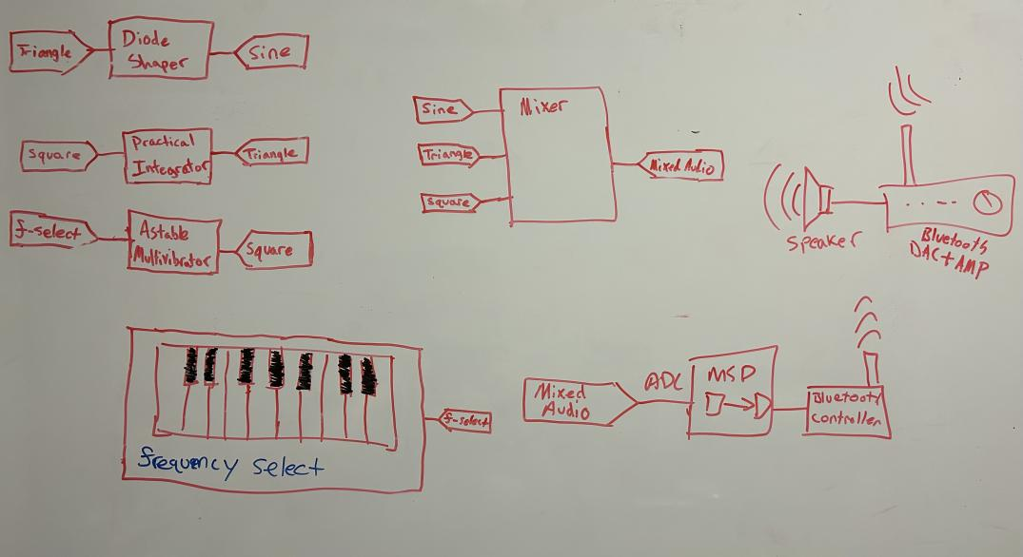

# High-Level, Behavior-Base System Operation

A keyboard of buttons selects how much resistance an astable multivibrator sees. This, in turn, allows the user to select a frequency for the square wave to be generated. This square wave is then put through an integrating amplifier to turn it into a triangle wave. The triangle wave is then put through a [6-diode diode shaper](https://www.multisim.com/content/v5kkSUdCsvbbX9TKSLkSSE/6-diode-3-segment-triangular-to-sine-wave-shaper/) to chop the triangle wave into a sine wave. These three signals are then mixed using a weighted summing amplifier, where each weight is adjustable through potentiometers. The mixed signal is pumped into the MSP430’s ADC to be transmitted into a bluetooth signal. The bluetooth signal is generated using a peripheral for the MSP430 that can connect to a bluetooth amplifier. This amplifier is plugged into a speaker and voila, a wondrous sound is created.

# Budget Breakdown

| Item | Quantity | Unit Price | Notes |
| --- | --- | --- | --- |
| Axial Through-hole resistors | ~25 | ~$0.10 | Probably 1% tolerance and of many values yet to be calculated |
| Through-hole ceramic capacitors | ~5 | ~$0.10 | Varying values between 1-10uF |
| LM324 Quad OpAmp | 2 | ~$0.54 | For oscillation, buffers, integration |
| Silicon diodes | 6 | ~$0.20 | For shaping the triangle wave into a “sine” wave |
| Buttons | 25 |  | For keyboard |
| Potentiometer (100k) | 3 |  | For tuning how much of each sound channel is in the output |
| MSP430 | 1 |  |  |
| Some kind of bluetooth host device for the MSP430 | 1 |  |  |
| Bluetooth DAC + AMP | 1 | Depends on specific item | We have one already, but if need be we can get a cheap one |
| Speaker | 1 | Free | Found on floor after ProfHacks |

# Team Work Plan

Considering that we spend a great deal of time together, we will most likely work on the project a few times a week in the evening. Not Thursday nights, as Elise has a class from 6:30-9:15 pm. Both the electrical and programming work will be a joint effort.